LAB ASSIGNMENT A2.1

Person

Background:

Now that you are familiar with drawing using processing, consider this very simple drawing:

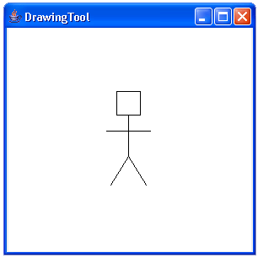

Assignment:

This program will use the processing library introduced in Lab A1. Refer to https://processing.org/ for reference material describing methods available in the PApplet class. Write a program that draws a simple stick figure person to the same window as the House you drew previously. You can make artistic modifications to your drawing, but your figure should not look more simplistic than the one above.

While getting a pretty drawing is good, the focus here is on the structure of your code. Attempt to create well-formed classes that are flexible to change. To do this, you should have:

- Multiple classes
- Each class has:
- Fields (properties of the object that can be changed)
- Constructor (initializes the fields)
- Methods (abilities the object can perform, or sub-steps of larger processes)
- Moderate documentation

